Ex1:

PROGRAM:

import java.io.IOException;

import javax.servlet.ServletException;

import javax.servlet.annotation.WebServlet;

import javax.servlet.http.HttpServlet;

import javax.servlet.http.HttpServletRequest;

import javax.servlet.http.HttpServletResponse;

/**

* Servlet implementation class Hello

*/

@WebServlet("/Hello")

public class Hello extends HttpServlet {

private static final long serialVersionUID = 1L;

/**

* Default constructor.

*/

public Hello() {

// TODO Auto-generated constructor stub

}

/**

* @see HttpServlet#doGet(HttpServletRequest request, HttpServletResponse response)

*/

protected void doGet(HttpServletRequest request, HttpServletResponse response) throws ServletException, IOException {

// TODO Auto-generated method stub

response.getWriter().append("hello servlet ");

}

}

OUTPUT:

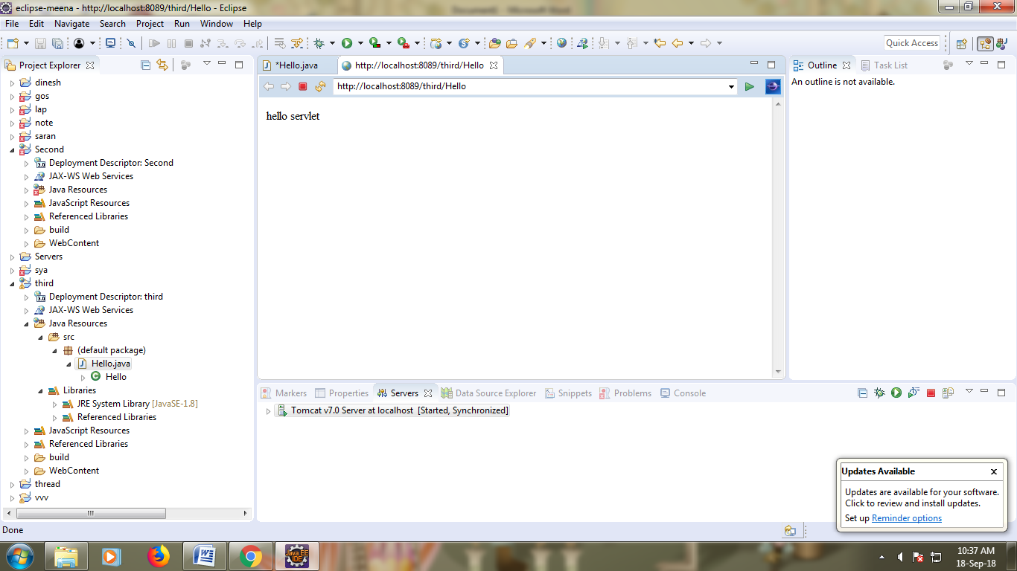

RESULT:

Ex2:

PROGRAM:

**import** java.io.IOException;

**import** java.io.PrintWriter;

**import** javax.servlet.ServletException;

**import** javax.servlet.annotation.WebServlet;

**import** javax.servlet.http.HttpServlet;

**import** javax.servlet.http.HttpServletRequest;

**import** javax.servlet.http.HttpServletResponse;

/**

* Servlet implementation class RequestInfo

*/

@WebServlet("/RequestInfo")

**public** **class** RequestInfo **extends** HttpServlet {

/**

*

*/

**private** **static** **final** **long** ***serialVersionUID*** = 1L;

**public** **void** doGet(HttpServletRequest request, HttpServletResponse response)

**throws** IOException, ServletException

{

response.setContentType("text/html");

PrintWriter out = response.getWriter();

out.println("<html>");

out.println("<body>");

out.println("<head>");

out.println("<title>Request Information Example</title>");

out.println("</head>");

out.println("<body>");

out.println("<h3>Request Information Example</h3>");

out.println("Method: " + request.getMethod());

out.println("<br>");

out.println("Request URI: " + request.getRequestURI());

out.println("<br>");

out.println("Protocol: " + request.getProtocol());

out.println("<br>");

out.println("PathInfo: " + request.getPathInfo());

out.println("<br>");

out.println("Remote Address: " + request.getRemoteAddr());

out.println("</br>");

out.println("</body>");

out.println("</html>");

}

/**

* We are going to perform the same operations for POST requests

* as for GET methods, so this method just sends the request to

* the doGet method.

*/

**public** **void** doPost(HttpServletRequest request, HttpServletResponse response)

**throws** IOException, ServletException

{

doGet(request, response);

}

}

OUTPUT:

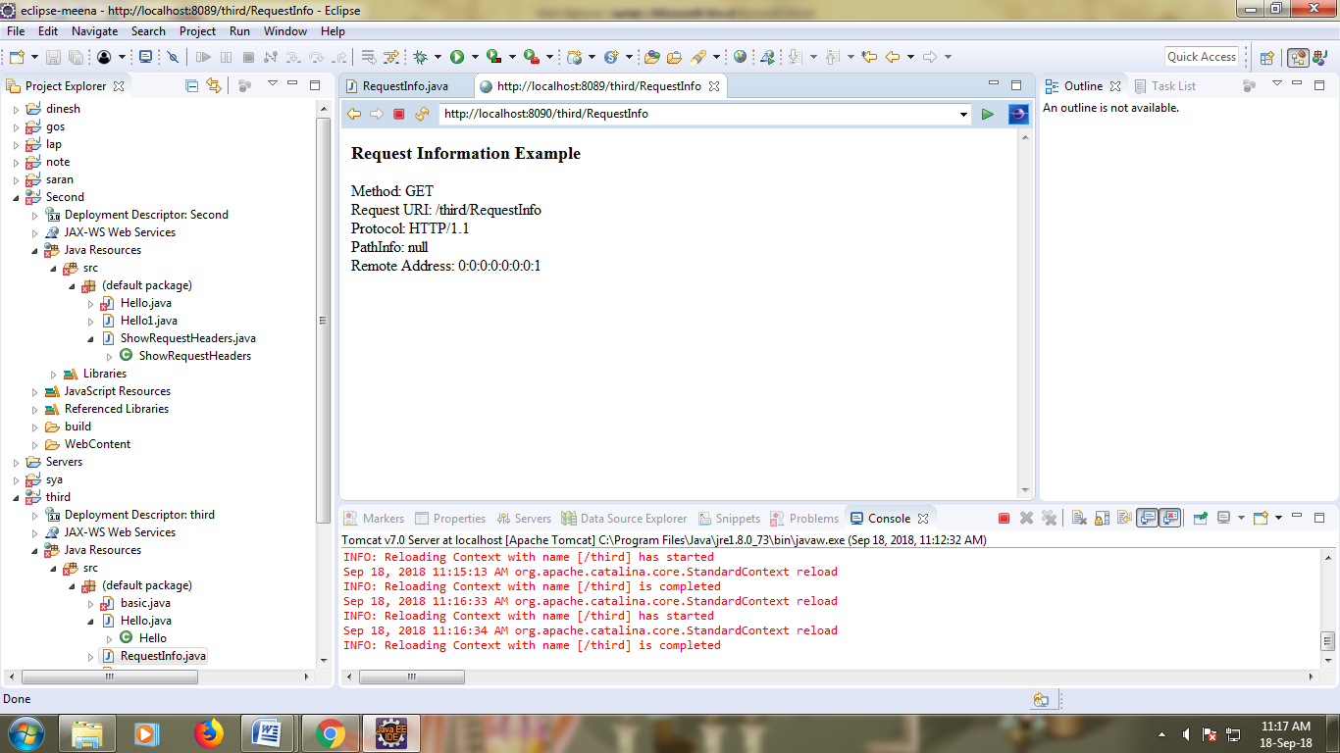

RESULT:

Ex3:

PROGRAM:

**import** java.io.IOException;

**import** java.io.PrintWriter;

**import** java.util.Enumeration;

**import** javax.servlet.ServletException;

**import** javax.servlet.annotation.WebServlet;

**import** javax.servlet.http.HttpServlet;

**import** javax.servlet.http.HttpServletRequest;

**import** javax.servlet.http.HttpServletResponse;

/**

* Servlet implementation class RequestHeaderExample

*/

@WebServlet("/RequestHeaderExample")

**public** **class** RequestHeaderExample **extends** HttpServlet {

**private** **static** **final** **long** ***serialVersionUID*** = 1L;

/**

* **@see** HttpServlet#doGet(HttpServletRequest request, HttpServletResponse response)

*/

**public** **void** doGet(HttpServletRequest request, HttpServletResponse response)

**throws** IOException, ServletException

{

response.setContentType("text/html");

PrintWriter out = response.getWriter();

Enumeration<String> e = request.getHeaderNames();

**while** (e.hasMoreElements()) {

String name = (String)e.nextElement();

out.println("<br>");

String value = request.getHeader(name);

out.println("<br>");

out.println(name + " = " + value);

}

}

}

OUTPUT:

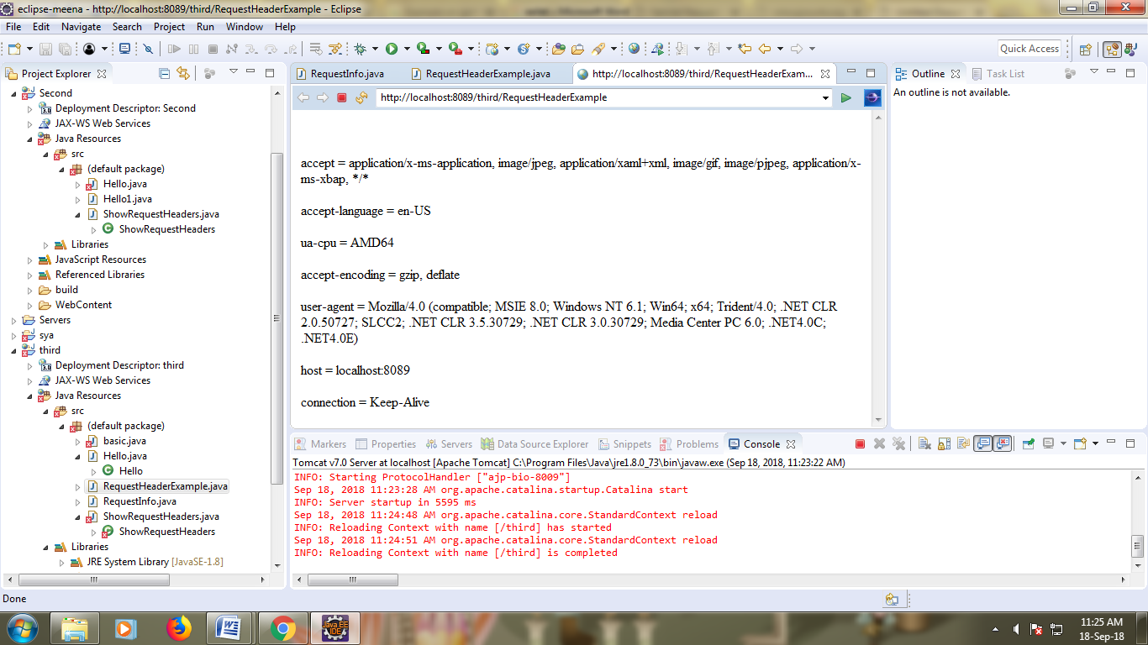

RESULT: